Operating Systems ( EXEC )

Program 1
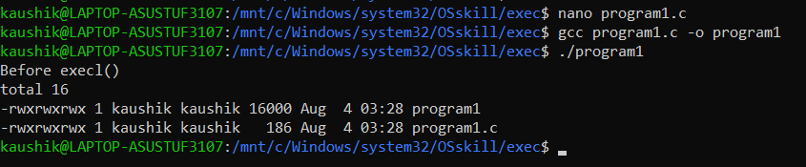

Program 2
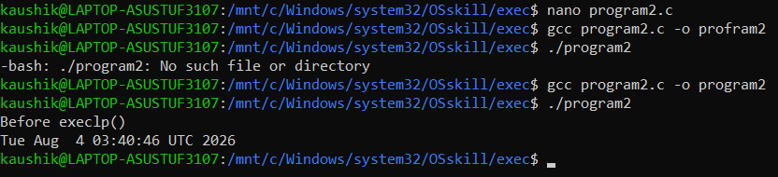
Program 3
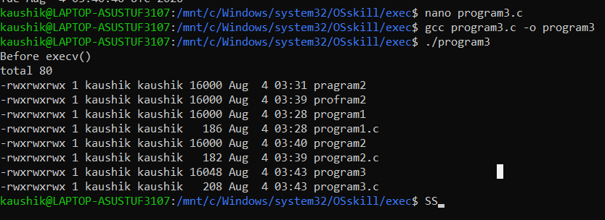
Program 5
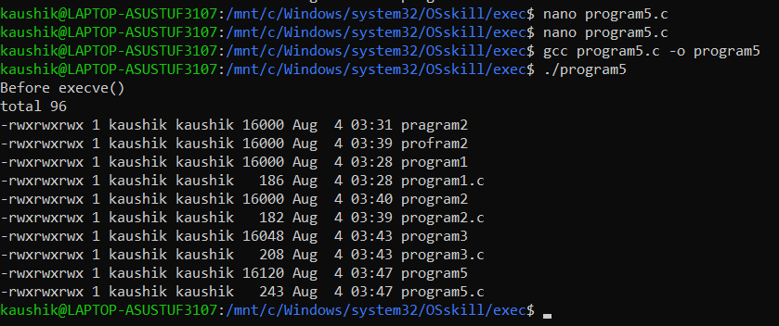

Program 4
